EENG 385 - Electronic Devices and Circuits

Frequency Domain: Active Filters

How To: Use Simulator to Build a Bode Plot Using Frequency Sweep Method

**How To: Simulation Bode Plot – Frequency Sweep**

In the previous How To, you built a Bode plot for the circuit shown in Figure 1.

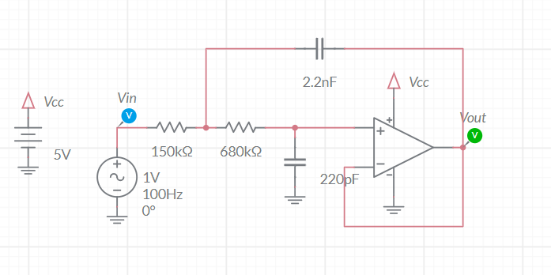

Figure : The low-pass filter on the Audio board is built around an op amp powered by 5V and gnd.

Now that you have gone through the painful process of building a Bode plot by hand, you will be delighted to know there is a far easier method to do this, have Multisim do it for you; the AC Sweep. The AC Sweep function runs a series of simulations, each:

* Will have an incrementally higher frequency for the AC source. You set the range of frequencies for the AC source,
* Will record the amplitude of each probe in the circuit in decibels with respect to the amplitude of the AC source,
* Will record the phase of each probe in the circuit in degrees with the phase of the AC source being 0°,

The Grapher will display the recorded data as magnitude and phase versus frequency. The frequency axis is logarithmic, forming a Bode plot for each probe in the circuit.

Let’s try this out for our low-pass filter. To start, you will need to change the simulation type to AC Sweep. Do this by clicking on the Interactive pull down shown below.

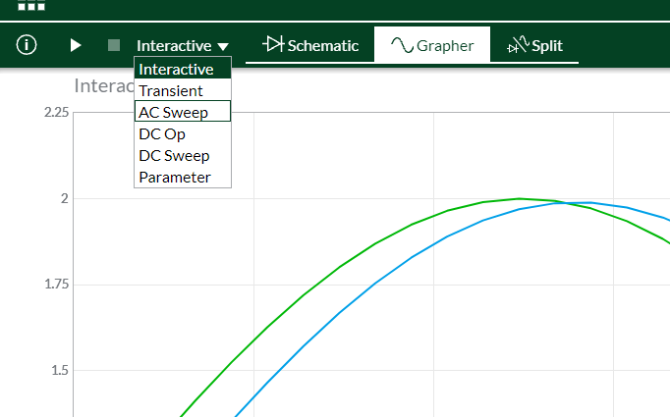

Next, you will need to configure the AC Sweep. Let’s create a Bode plot using the same frequencies you used to create your Bode plot in Excel. Double click on the schematic to reveal the simulation settings pull-out. We will use the following settings to duplicate the measurements you made when you manually collected the data (except for the points per decade).

* Start frequency 1Hz
* Stop frequency 47kHz
* Points per decade 20
* Vertical scale Decibels

Now run the simulation. On the Grapher output, isolate the phase and magnitude of Vout by removing the phase and magnitude of Vin by clicking on the filled check boxes by their names in the pull-out. The Grapher output has the attenuation scale on the left axis and the phase scale on the right side of the graph.

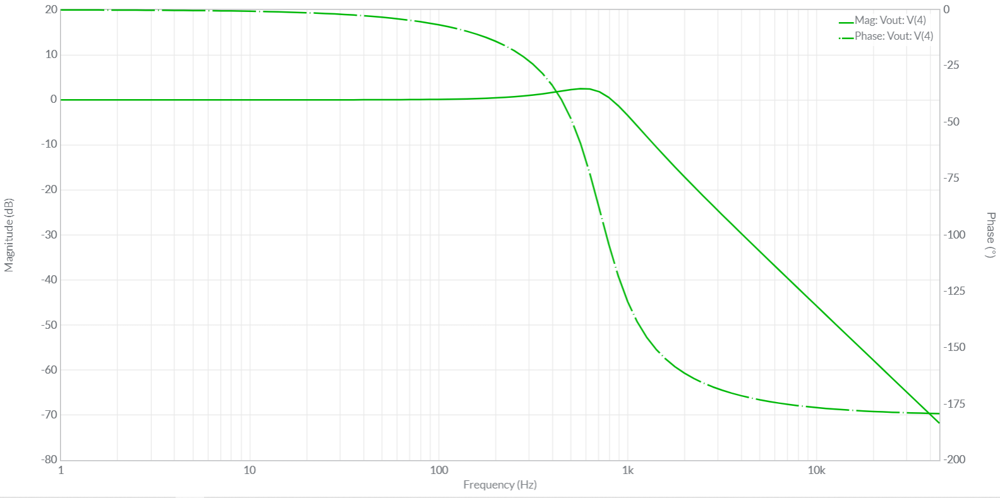

Figure : The grapher output after running a frequency sweep on the circuit in .

You can download a nice image of the Grapher output by clicking on the 3x3 grid of squares in the upper left corner of the Multisim window and selecting Export -> Grapher image. Your browser should download the png file.